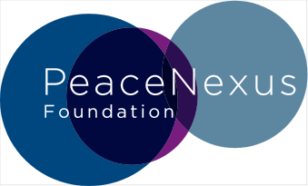
ORGANISATIONAL DEVELOPMENT SUPPORT FOR INTERNATIONAL PARTNERS
APPLICATION FORM
(SHORT ANSWERS – 5 PAGES MAXIMUM)

ALL INFORMATION PROVIDED IS TREATED AS CONFIDENTIAL
Information about your organisation
- Please point us to where we can find on-line (or attach to application):
- Your organisation’s mission and current priorities
- Your organisation’s contribution to peacebuilding policy and practice – up to now and as you envision it in the future.
- Evidence of the results of your work (case-studies, impact stories, external evaluations, etc.)
- How has the organisation been impacted by the polycrisis that is affecting the sector, what internal adaptations have you had to make already?

Organisational Development
- Internal alignment
- Describe your organisational management and governance structures as they were intended and as they are currently functioning with each other.
- Where do you want to make more progress in terms of aligning your internal practices with your core values and why?
- What key challenges are you encountering and how do they impact your work and ability to pursue your objectives as an organisation?
- What first steps have you taken and how would an externally supported change process be helpful and timely?
- Building equitable partnerships
- Reflect on how you work with your partners, how has that practice evolved?
- Where do you want to make changes to your partnership model with local actors and why? Please provide concrete practical examples.
- What challenges are you encountering and how do they impact your work and ability to pursue your objectives as an organisation?
- What first steps have you taken and how would an externally supported change process be helpful and timely?

- Should you focus on one organisational development priority, what would that be and why? What could success look like?
- How has this application been developed and who has been involved? If selected, who do you expect to be directly involved in the OD process?
- Is there anything else you would like to share with us at this time?

